

|  |  |  |
| --- | --- | --- |
| Mathematics Department | |  |
| Course: A2MAA | |
| Topic Title: Test 2 | |
| Student Name:_____________________________________ | Date: _______________2016 | | |
| Special Instructions: Formula Sheet, 1 page of double sided A4 notes and calculators allowed. | Time Allowed: 50 minutes | | |
|  | Marks: / 40 | | |

**Question 1 (4 marks)**

Use the triangle below to obtain the fractions for the trigonometric ratios given.

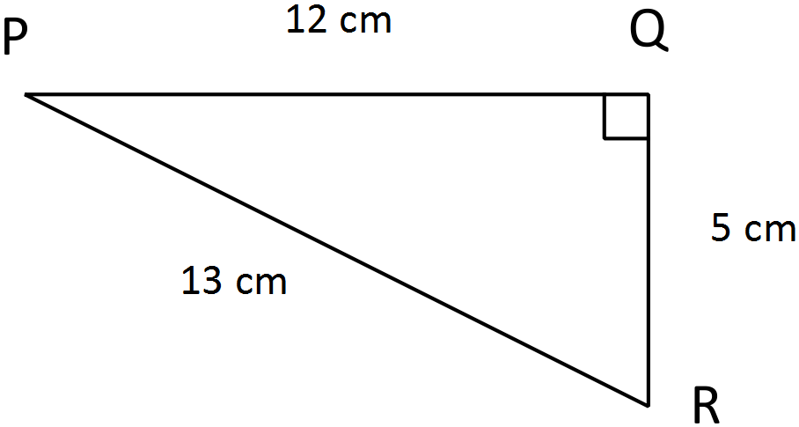

1. sin *P* = _________
2. sin *R* = _________
3. cos *R* = ________
4. tan *P* = ________

**Question 2 (2 marks)**

Calculate the length of the missing side.

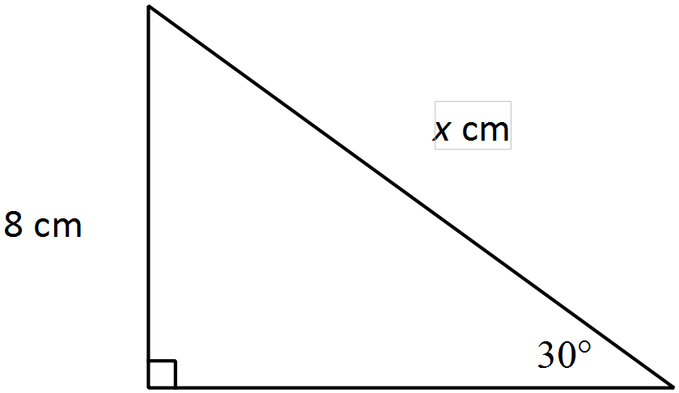

**Question 3 (2 marks)**

Calculate the bearing of A from B in the following two scenarios.

1. b)

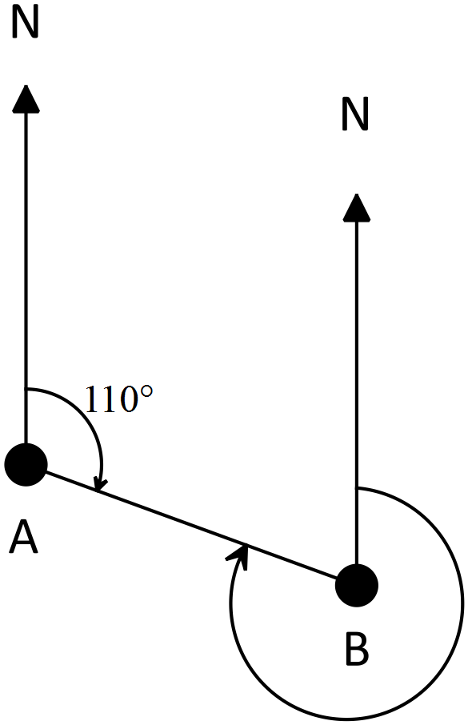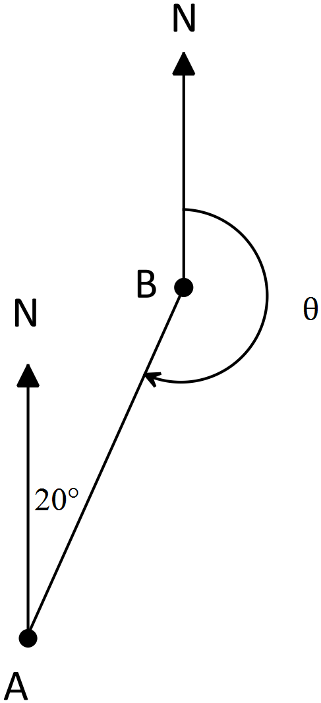

**Question 4 (2 marks)**

Calculate the area of the triangle below.

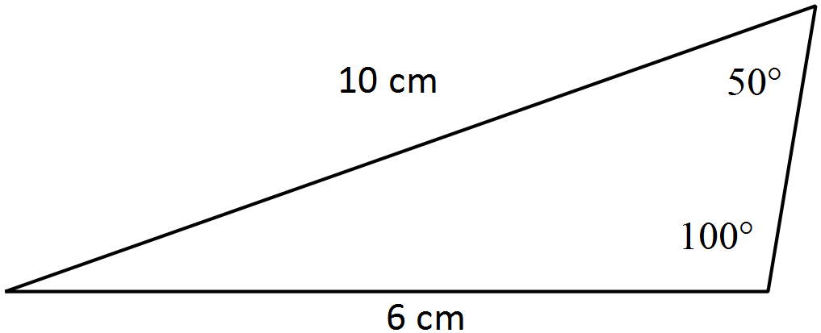

**Question 5 (4 marks)**

Find the value of $x$ in each of the following. (diagrams are not to scale)

1. (2 marks)

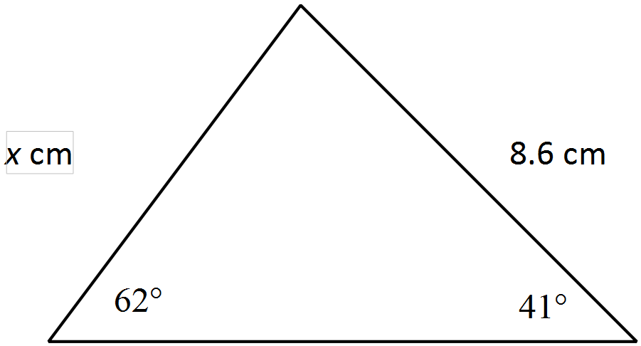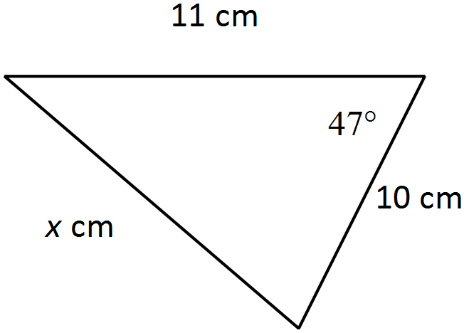

b) (2 marks)

**Question 6 (3 marks)**

A ladder leans against a wall inclined at an angle 27° to the horizontal. If the ladder reaches 7.5m up the wall, what is the length of the ladder?

**Question 7 (3 marks)**

A triangle has an area of 767.69 cm2. The lengths of two of the sides of the triangle are 43.1cm and 38.7cm. Find the size of the angle between these two sides.

**Question 8 (6 marks)**

From the top of the cliff, ship A is observed at an angle of depression of 15°, 35m from the base of the cliff. At the same time ship B is observed 12m from ship A as shown in the diagram below.

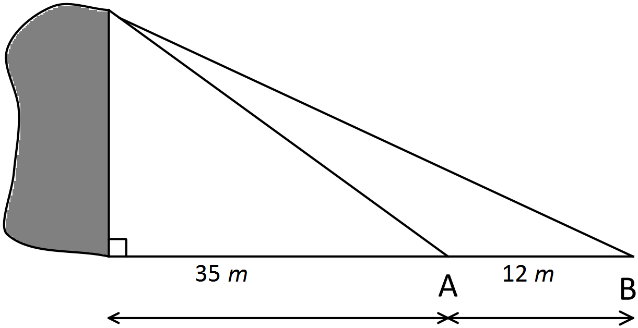

Determine:

1. The height of the cliff (4 marks)
2. The angle of elevation from ship B to the top of the cliff (2 marks)

**Question 9. (4 marks)**

Consider the triangle below.

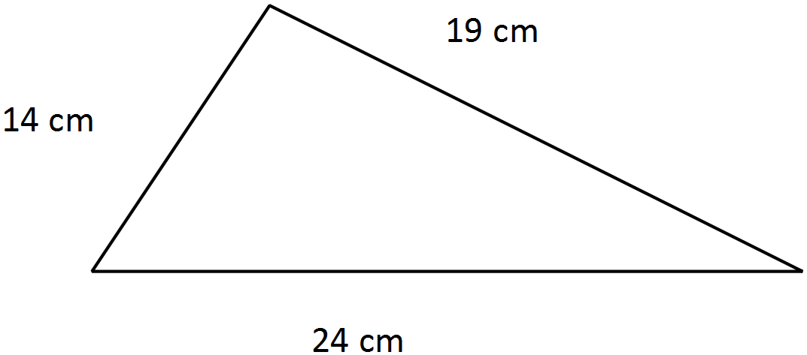

Use Heron’s formula to calculate the area of this triangle.

**Question 10 (10 marks)**

Ship A leaves port P travelling 120km west. Ship B leaves port on a bearing of 215° travelling 120km.

Find:

1. Draw a diagram to show this. (2 marks)
2. the distance between the two ships (2 marks)
3. the bearing of ship A from ship B (4 marks)
4. the bearing of ship B from ship A (2 marks)